Artificial Intelligence Lab

Lab Manual 07

(Best First Search, Beam Search, and A*)



Department of Cyber Security

HITEC University Taxila

Objectives
This lab will introduce students to informed search problems. Students will perform a basic Best First Search, Beam Search, and A* Algorithms. The output will be a set of actions or a path that begins from the initial state/node and ends at the goal node.

Software
Python, Pycharm or VS-Code IDE

Theory

Informed Search
Informed search algorithms, also known as heuristic search algorithms, incorporate problem-specific knowledge or additional information to guide the search process towards the goal state more efficiently. This additional information is typically provided by a heuristic function, which estimates the cost or distance from a given state to the goal state. Informed search algorithms make use of this heuristic information to prioritize certain paths over others, aiming to reach the goal state more quickly. Examples of informed search algorithms include:
- Best First Search Algorithm
- Beam Search Algorithm
- A* Search Algorithm
- AO* Search Algorithm

Informed search algorithms tend to be more efficient in terms of time and memory compared to uninformed search algorithms, especially when the search space is large or the problem is complex. However, the effectiveness of an informed search algorithm heavily depends on the quality of the heuristic function used.

3.1 Best-First Search
Best First Search is a heuristic search algorithm that selects the most promising node for expansion based on an evaluation function. It prioritizes nodes in the search space using a heuristic to estimate their potential. It aims to efficiently navigate towards the goal state by iteratively choosing the most promising node, making it particularly effective for optimization problems.
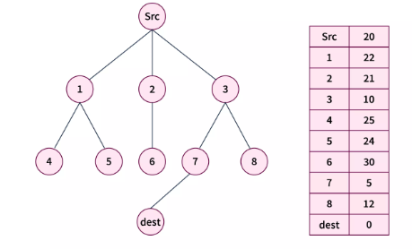

Traversing Child Nodes
Step 1 - Initialize two empty lists i.e.i.e. openList and closeList.
Step 2- Insert src in the openList, after which we have - openList = [src] closeList = []
Step 3 - (Iterating while the open list is not empty) -
- Iteration 1 -
  - After this operation we will have - openList = [1, 2, 3], closeList = [src]
- Iteration 2 -
  - After this operation we will have - openList = [1, 2, 7, 8] closeList = [src, 3]
- Iteration 3 -
  - Upon exploring the adjacents of node 7 we found that dest is one of them. Hence, we return that search result in success, and print the path src→3→7→destsrc→3→7→dest.

Complexity:
Time Complexity: O(n * log n), where n is the number of nodes. In the worst case, we may have to visit all nodes before we reach the goal.

Real-World Applications of BFS:
Today, this algorithm is widely used in many problem domains, including robotics, natural language processing, computer vision, game playing, and optimization. Its ability to find optimal solutions efficiently and its adaptability to various problem domains make the Best-First Search Algorithm a powerful tool in these fields.

Implementation in Python:
import heapq

# Graph adjacency list
graph = {
'Src': ['1', '2', '3'],
'1': ['4', '5'],
'2': ['6'],
'3': ['7', '8'],
'4': [], '5': [], '6': [], '7': ['dest'], '8': ['dest'], 'dest': []
}

# Heuristic values for Best First Search (lower is better)
heuristics = {
'Src': 20,
'1': 22, '2': 21, '3': 10,
'4': 25, '5': 24, '6': 30,
'7': 5, '8': 12,
'dest': 0
}

def best_first_search(graph, heuristics, start, goal):
# Priority Queue to always choose node with lowest heuristic
open_set = []
heapq.heappush(open_set, (heuristics[start], start))

visited = set()
parent = {start: None}

while open_set:
h, current = heapq.heappop(open_set)
print(f"Visiting: {current}")

if current == goal:
# Reconstruct the path from parent dictionary
path = []
while current:
path.append(current)
current = parent[current]
path.reverse()
return path

visited.add(current)

# Explore all neighbors
for neighbor in graph[current]:
if neighbor not in visited:
heapq.heappush(open_set, (heuristics[neighbor], neighbor))
parent[neighbor] = current

return None # Goal not found

# Run Best First Search
path = best_first_search(graph, heuristics, 'Src', 'dest')
print("Best First Search Path:", path)

OUTPUT:
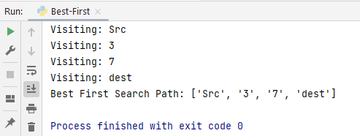

3.2 Beam Search Algorithm
Beam Search is an optimized version of Best-First Search that limits the number of nodes stored in memory. It explores only the “best” few nodes at each level, instead of all possible nodes. Designed to reduce memory and computation requirements while maintaining good search quality.
  - How It Works

Start from the initial node.

Generate all possible successors (children).

Rank them based on heuristic value (like in Best-First Search).

Select only the top ‘k’ nodes (where k = beam width).

Expand those nodes in the next iteration.

Repeat until goal is reached or no better nodes are found.

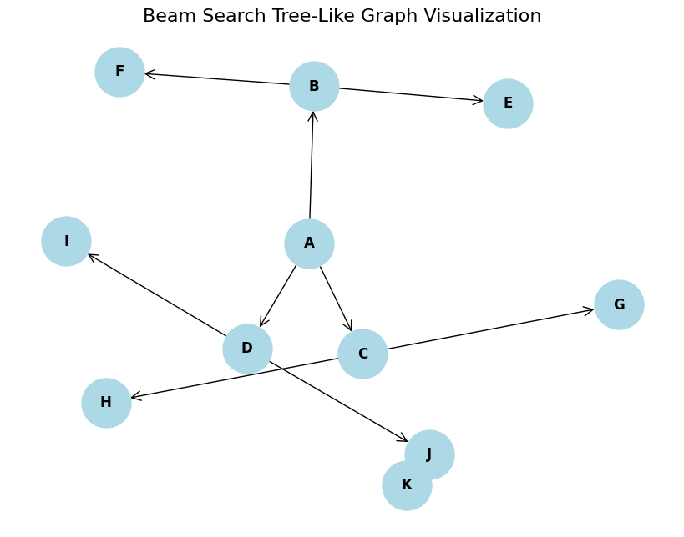

Implementation in Python:
import heapq
# Define a complex graph with heuristic values
graph = {
'A': ['B', 'C', 'D'],
'B': ['E', 'F'],
'C': ['G', 'H'],
'D': ['I', 'J'],
'E': [],
'F': [],
'G': [],
'H': [],
'I': [],
'J': ['K'],
'K': []
}

# Heuristic values (lower is better)
heuristics = {
'A': 10,
'B': 8,
'C': 7,
'D': 6,
'E': 5,
'F': 4,
'G': 6,
'H': 3,
'I': 9,
'J': 2,
'K': 0 # Goal node
}

def beam_search(graph, heuristics, start, goal, beam_width):
from collections import deque

queue = deque([[start]]) # Each element is a path
while queue:
candidates = []

# Expand all paths in the current beam
while queue:
path = queue.popleft()
node = path[-1]

if node == goal:
print(f"Goal '{goal}' found! Path: {' -> '.join(path)}")
return path

for neighbor in graph.get(node, []):
new_path = path + [neighbor]
candidates.append((heuristics[neighbor], new_path))

# Select top-k paths based on heuristic
candidates.sort(key=lambda x: x[0])
queue = deque([path for _, path in candidates[:beam_width]])

print(f"Goal '{goal}' not found within beam width {beam_width}")
return None

# Example usage
start_node = 'A'
goal_node = 'K'
beam_width = 2

beam_search(graph, heuristics, start_node, goal_node, beam_width)

Output:
Goal 'K' found! Path: A -> D -> J -> K
['A', 'D', 'J', 'K']

3.3 A* algorithm
A* Search is an informed best-first search algorithm that efficiently determines the lowest cost path between any two nodes in a directed weighted graph with non-negative edge weights.
f(x) = g(x) + h(x)
Where g(x) represents the cost to get to node x , and h(x) represents the estimated cost to arrive at the goal node from node x.

Complexity:
Time Complexity: O(V+Elog(V)), where e edges and V are vertices(nodes).

Real-World Applications of A*:
- Pathfinding in Games: A* algorithm is used in Artificial Intelligence Video Games where non-player characters, commonly known as bots, find the shortest path throughout the game.
- Robotics: This algorithm also helps robots navigate through environments, avoiding obstacles.
- GPS Navigation: This algorithm is preferred to find the best and most efficient route between two points.
- Puzzle Solving: Puzzles where the target is to reach a goal from an initial position, such as 8-puzzle or sliding puzzles, take the help of A* Search Algorithm.

Traversal
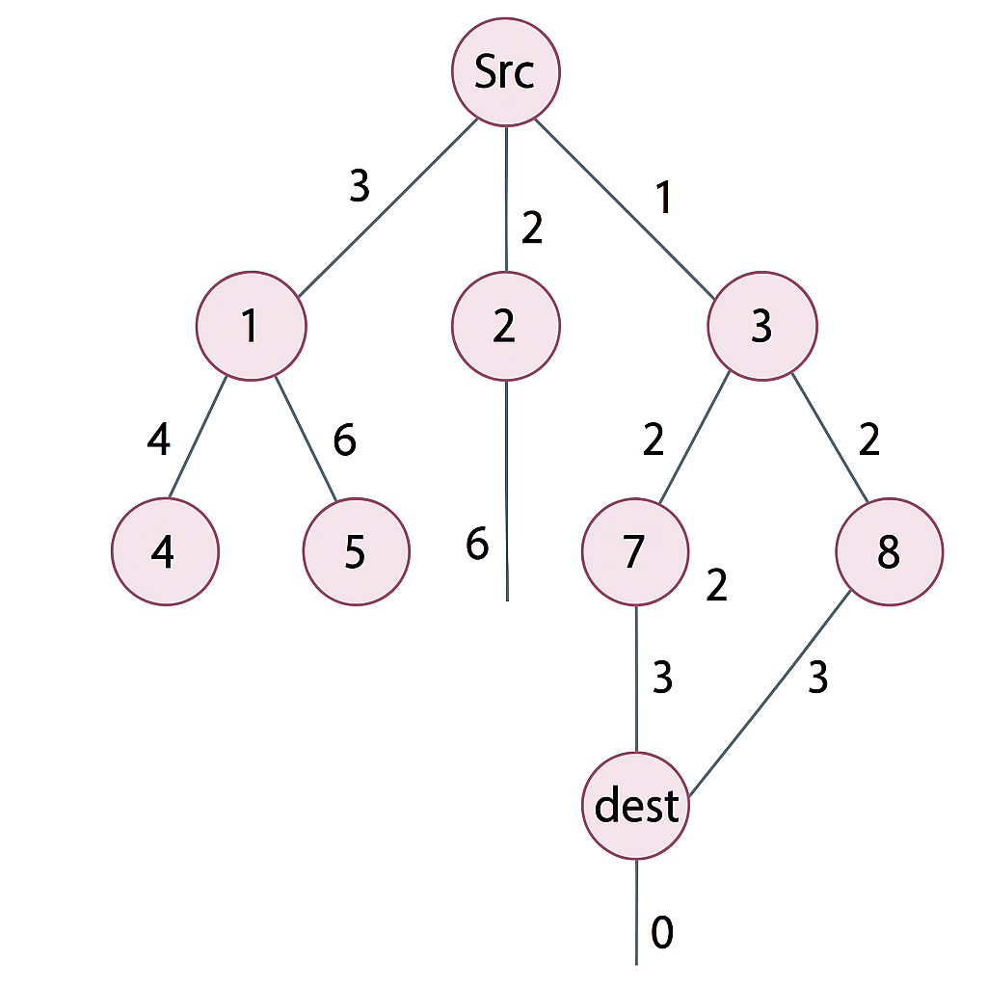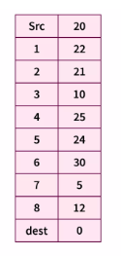
6
- g(n) is the actual cost from the source to the current node.
- h(n) is the heuristic value from the current node to the destination.
- f(n) = g(n) + h(n) is used to determine the next node to explore.
- We use a min-heap (priority queue) via heapq to always explore the most promising node next.

Implementation in Python:
import heapq
# Define the graph with edge costs (g(n))
graph = {
'Src': [('1', 3), ('2', 2), ('3', 1)],
'1': [('4', 4), ('5', 6)],
'2': [('6', 6)],
'3': [('7', 2), ('8', 2)],
'4': [],
'5': [],
'6': [],
'7': [('dest', 3)],
'8': [('dest', 3)],
'dest': []
}

# Define the heuristic values (h(n))
heuristics = {
'Src': 20,
'1': 22,
'2': 21,
'3': 10,
'4': 25,
'5': 24,
'6': 30,
'7': 5,
'8': 12,
'dest': 0
}

# A* algorithm
def a_star(graph, heuristics, start, goal):
open_set = []
heapq.heappush(open_set, (heuristics[start], 0, start, [start]))

while open_set:
f, g, current, path = heapq.heappop(open_set)

if current == goal:
return path, g # Return path and total cost

for neighbor, cost in graph[current]:
new_g = g + cost
new_f = new_g + heuristics[neighbor]
heapq.heappush(open_set, (new_f, new_g, neighbor, path + [neighbor]))

return None, float('inf')

# Run the A* algorithm
path, total_cost = a_star(graph, heuristics, 'Src', 'dest')
print("A* Path:", path)
print("Total Cost:", total_cost)

OUTPUT:
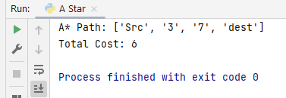

Lab Task

- Apply the Best First Search and Beam Search algorithm on the graph below. Root Node is (a) and goal node is (z).
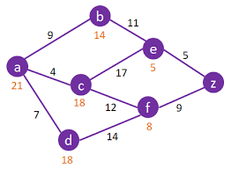
- Apply Best First Search, Beam Search algorithm and A* on the graph below.
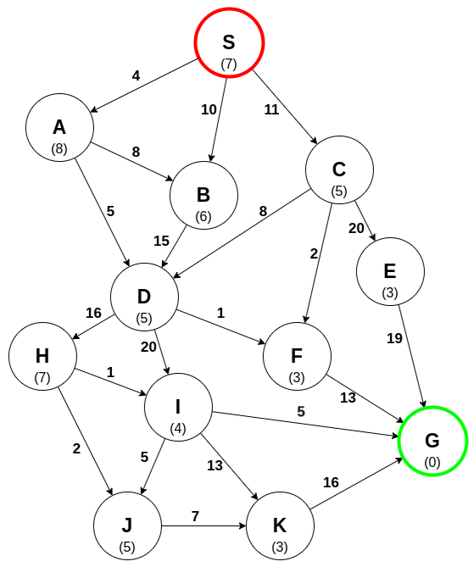

Conclusion

